# **Assignment-I**

Write PL/SQL queries for the following

1) Create tables for - Student(student_id, first_name, last_name, dept, Date_of_birth, gender,

religion), Employee, Product, Customer, and Account. Identify relevant attributes for each table

and make sure each table has at least four columns. Ensure each table has a _ID column e.g.

Employee should have EMPLOYEE_ID column, Student should have STUDENT_ID column

etc.

🡺

i) **Student table**

CREATE TABLE Student (

student_id INT,

first_name VARCHAR(10),

last_name VARCHAR(10),

dept VARCHAR(10),

Date_of_birth DATE,

gender CHAR(6),

religion VARCHAR(10)

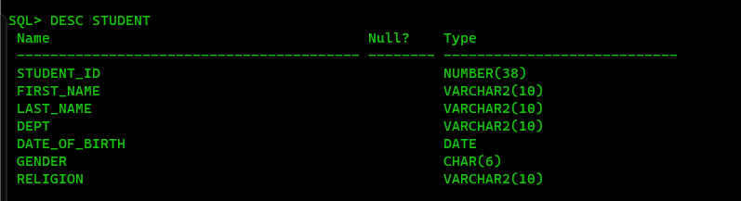);

II)**Employee table**

CREATE TABLE Employee (

EMPLOYEE_ID NUMBER,

FIRST_NAME VARCHAR2(10),

LAST_NAME VARCHAR2(10),

DEPT VARCHAR2(10),

DATE_OF_BIRTH DATE,

GENDER VARCHAR2(6),

RELIGION VARCHAR2(10) );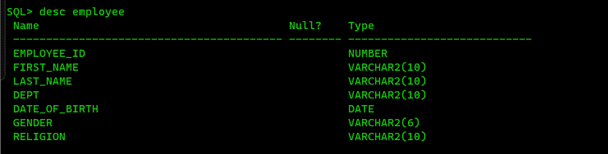

III) Product table

CREATE TABLE Product (

PRODUCT_ID NUMBER,

PRODUCT_NAME VARCHAR2(10),

CATEGORY VARCHAR2(10),

PRICE NUMBER(10, 2),

MANUFACTURER VARCHAR2(10)

);

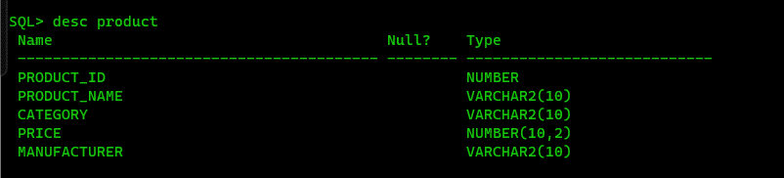

iv) Customer table

CREATE TABLE Customer (

CUSTOMER_ID NUMBER ,

FIRST_NAME VARCHAR2(10),

LAST_NAME VARCHAR2(10),

EMAIL VARCHAR2(15),

PHONE_NUMBER VARCHAR2(10)

);

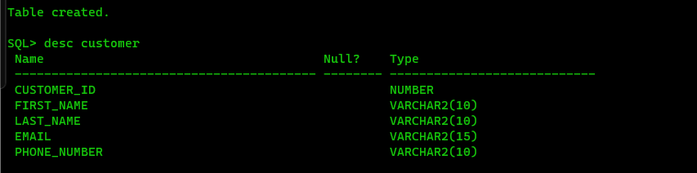

v) Account table

CREATE TABLE Account (

ACCOUNT_ID NUMBER,

ACCOUNT_NUMBER VARCHAR2(10),

ACCOUNT_TYPE VARCHAR2(10),

BALANCE NUMBER(15, 2),

OPEN_DATE DATE

);

2. Describe each table.

🡺

1. **Student Table:**
   * **STUDENT_ID:** Unique identifier for each student.
   * **FIRST_NAME:** First name of the student.
   * **LAST_NAME:** Last name of the student.
   * **DEPT:** Department to which the student belongs.
   * **DATE_OF_BIRTH:** Date of birth of the student.
   * **GENDER:** Gender of the student.
   * **RELIGION:** Religion of the student.
2. **Employee Table:**
   * **EMPLOYEE_ID:** Unique identifier for each employee.
   * **FIRST_NAME:** First name of the employee.
   * **LAST_NAME:** Last name of the employee.
   * **DEPT:** Department to which the employee belongs.
   * **DATE_OF_BIRTH:** Date of birth of the employee.
   * **GENDER:** Gender of the employee.
   * **RELIGION:** Religion of the employee.
3. **Product Table:**
   * **PRODUCT_ID:** Unique identifier for each product.
   * **PRODUCT_NAME:** Name of the product.
   * **CATEGORY:** Category to which the product belongs.
   * **PRICE:** Price of the product.
   * **MANUFACTURER:** Manufacturer of the product.
4. **Customer Table:**
   * **CUSTOMER_ID:** Unique identifier for each customer.
   * **FIRST_NAME:** First name of the customer.
   * **LAST_NAME:** Last name of the customer.
   * **EMAIL:** Email address of the customer.
   * **PHONE_NUMBER:** Phone number of the customer.
5. **Account Table:**
   * **ACCOUNT_ID:** Unique identifier for each account.
   * **ACCOUNT_NUMBER:** Account number associated with the account.
   * **ACCOUNT_TYPE:** Type of the account (e.g., savings, checking).
   * **BALANCE:** Current balance in the account.
   * **OPEN_DATE:** Date when the account was opened.

3. Insert at least 5 distinct rows to each table.

🡺 **Student table**

insert into Student values (01, 'Bibek', 'Sah', 'CSE', '02-jan-2002', 'Male', 'Hinduism');

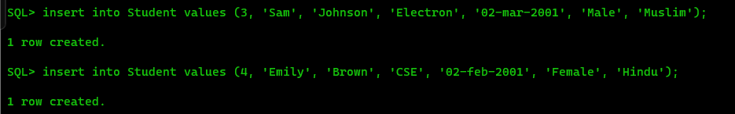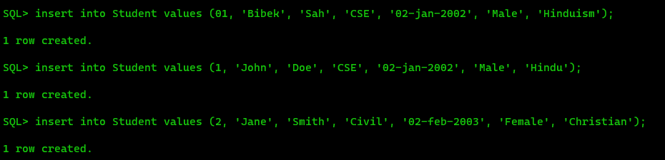

**Employee table**

INSERT INTO Employee (EMPLOYEE_ID, FIRST_NAME, LAST_NAME, DEPT, DATE_OF_BIRTH, GENDER, RELIGION) VALUES (101, 'Alice', 'Johnson', 'HR', '02-mar-1980', 'Female', 'None');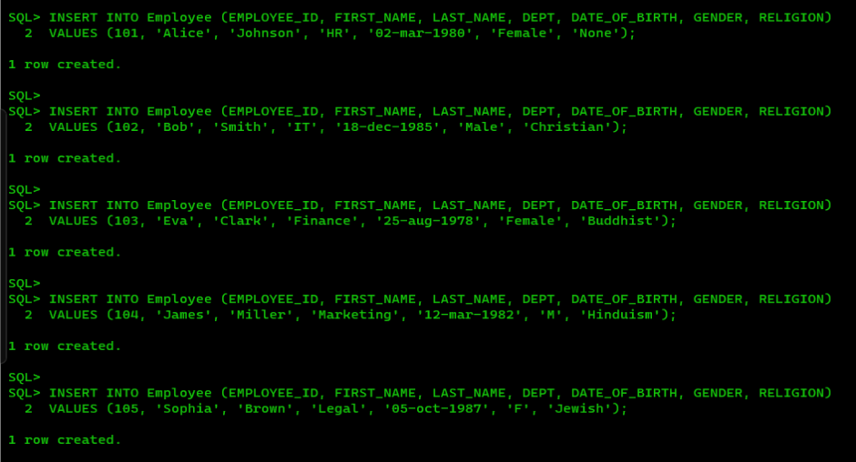

**Product table**

INSERT INTO Product (PRODUCT_ID, PRODUCT_NAME, CATEGORY, PRICE, MANUFACTURER) VALUES (501, 'Laptop', 'Electronic', 1200.00, 'HP');

**Customer table**

INSERT INTO Customer (CUSTOMER_ID, FIRST_NAME, LAST_NAME, EMAIL, PHONE_NUMBER) VALUES (1001, 'David', 'Johnson', 'david@em.co', '1234567890');

**Account table**

INSERT INTO Account (ACCOUNT_ID, ACCOUNT_NUMBER, ACCOUNT_TYPE, BALANCE, OPEN_DATE) VALUES (10001, 'A123456', 'Savings', 5000.00, '01-jan-2022');

4. Fetch all data from the respective tables.

🡺student table:- select * from student;

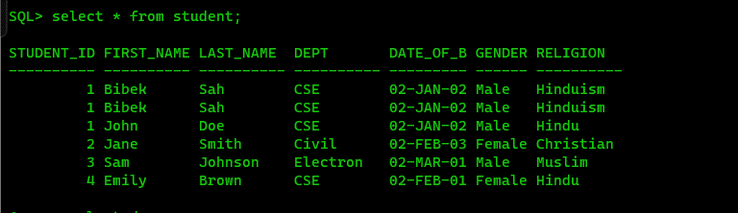

Employee table:- select * from employee;

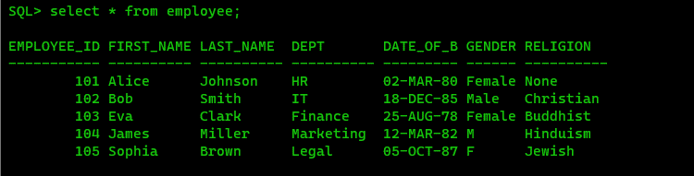

Product table :- select * from product;

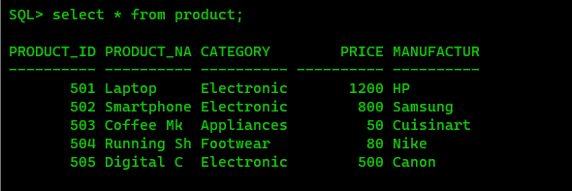

Account table :- select * from account;

5. Fetch Employee ids and their names from the Employee table.

🡺 select employee_id, first_name from employee;

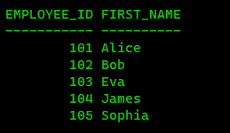

6. Create table YOUTH (f_name, l_name, sex, DOB) from the Student table.

🡺 CREATE TABLE YOUTH AS SELECT FIRST_NAME AS f_name, LAST_NAME AS l_name, GENDER AS sex, DATE_OF_BIRTH AS DOB FROM Student;

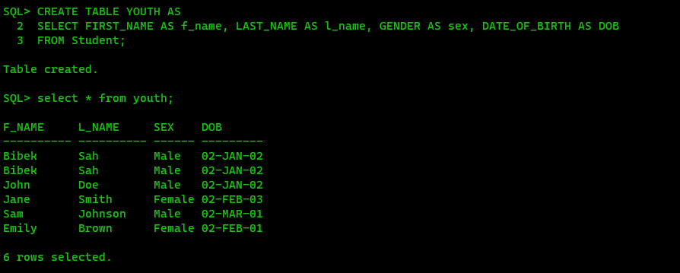

7. Delete all data from the customer table.

🡺 DELETE FROM Customer;

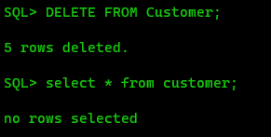

8. Delete the Account table.

🡺 drop table account;

9. Fetch the f_name and DOB from YOUTH table.

🡺 SELECT f_name, DOB FROM YOUTH;

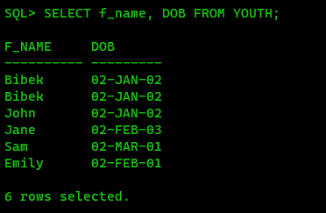

10. Insert a new record into the Youth table. And keep NULL value in the l_name column.

🡺 INSERT INTO YOUTH (f_name, l_name, sex, DOB) VALUES ('John', NULL, 'Male', '15-jan-2000');

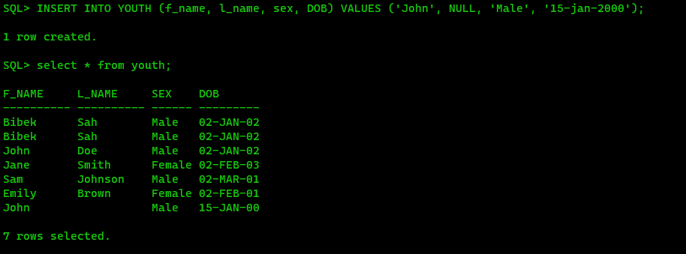

11. Insert a new record into the Employee table. And keep NULL value in the employee_id

column.

🡺 insert into Employee (Employee_id, Employee_name, Product, Customer, Account) values ('null’, ‘Raman’, ‘Charger’, ‘Rajkumar’, 2000);

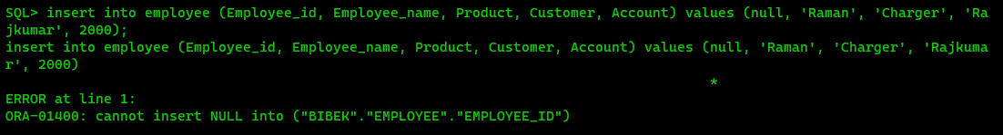

12. Change the name of the employee table to workers.

🡺RENAME EMPLOYEE TO WORKERS;

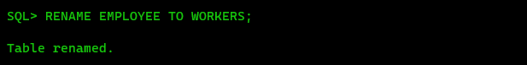

13. Increase the size of the dept field in the student table by 10.

🡺ALTER TABLE STUDENT MODIFY DEPT VARCHAR(10);

14. Add a column ph_no in the student table.

🡺 ALTER TABLE STUDENT ADD PH_NO VARCHAR(10);

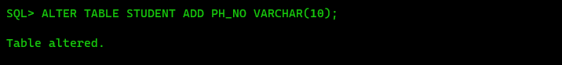

15. Drop the religion attribute from the student table.

🡺 ALTER TABLE STUDENT SET UNUSED COLUMN RELIGION;

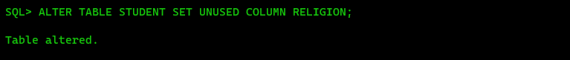

16. Rename the student_id field to roll_no in the student table.

🡺 ALTER TABLE STUDENT RENAME COLUMN STUDENT_ID TO ROLL_NO;

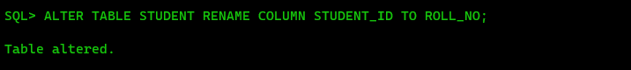

17. Change the datatype and size of the product id column in the product table.

🡺

# **Assignment-II**

Q1: Create a new user making “your_name” as user-name and “your_surname” as the password.

🡺create user bibek identified by root;

Q2: Grant all privileges to the newly created user.

🡺 grant all privileges to bibek;

Q3: connect to the new user.

🡺connect

Q4: Create a table employee with attributes emp_id, f_name , l_name , job_type, salary, commision, dept, and manager_id.

🡺 CREATE TABLE Employee (

employee_id INT,

first_name VARCHAR(10),

last_name VARCHAR(10),

job_types varchar(10),

salary number,

commission number,

dept VARCHAR(10),

manager_id number);

Q5: Describe the table employee

🡺 DESC employee

Q6: Add a new column doj to the employee table.

🡺alter table employee add doj date;

Q7: Create a new table department with attributes d_name, d_loc, and hod_id.

🡺 CREATE TABLE department ( d_name VARCHAR(10), d_loc VARCHAR(10), hod_id number);

Q8: Create another table named location with attributes loc_id, city and contact_no.

🡺 CREATE TABLE location ( loc_id number, city VARCHAR(10), contact number);

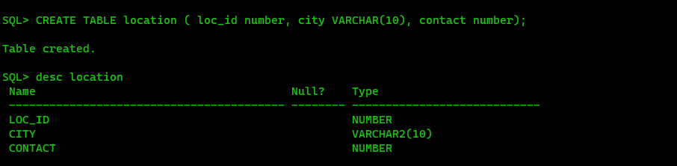

Q9. Enhance the size of city attribute in location table by 5.

🡺 ALTER TABLE location MODIFY city VARCHAR(5);

Q10. Delete the contact_no attribute in the location table.

🡺 ALTER TABLE location SET UNUSED COLUMN contact;

Q11. Rename the city attribute in the location table to address.

🡺 ALTER TABLE location RENAME COLUMN city TO address;

Q12. Change the name of the table from location to loc.

🡺 RENAME location To loc;

Q13. Insert the following values into the loc table.

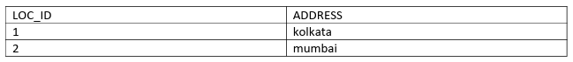

🡺 insert into loc values (01, 'Kol');

Q14. Show the values of location table.

🡺 select * from loc;

Q15. Delete all values and spaces consumed by loc table.

🡺 TRUNCATE TABLE loc;

Q16. Delete the loc table.

🡺 drop table loc;

Q17. Insert the following values into the department table.

🡺 insert into department values ('&d_name', '&d_loc', &hod_id);

Q18. Insert the following values into the employee table.

🡺 insert into employee values (&employee_id, '&first_name', '&last_name', '&job_type', &salary, &commission, '&dept', &manager_id, '&doj');

Q19. Save the database.

🡺commit;

Q20: Show all the attribute values of the department table.

🡺 select * from department;

Q21: Display the department names and their locations.

🡺 select d_name, d_loc from department;

Q22: Show the employee’s first name, last name, current salary and the salary with a 1000 rupees bonus.

🡺 SELECT first_name, last_name, salary, salary + 1000 AS Salary_With_Bonus FROM employee;

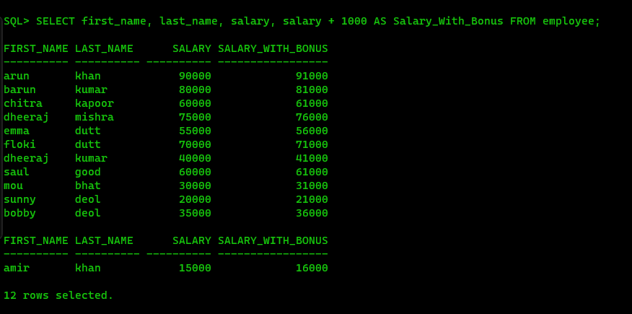

Q23: Show the employee’s annual salary with a 1000 rupees yearly bonus and the annual salary with a 100 rupees monthly bonus.

🡺 SELECT first_name, last_name, salary * 12 + 1000 AS Yearly_Bonus, (salary + 100) * 12 AS Monthly_Bonus FROM employee;

Q24: Show f_name as Name and annual salary as ANNSAL from the employee table.

🡺 SELECT first_name AS Name, salary * 12 AS ANNSAL FROM employee;

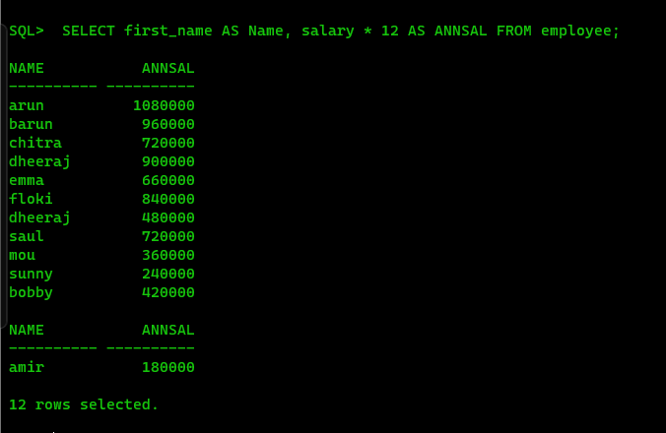

Q25: Show the L_name as SurName and 100 rupees incremented salary as NewSal from the employee table.

🡺 SELECT last_name AS SurName, salary + 100 AS NewSal FROM employee;

Q26: Display the employees f_name and l_name joined together using the concatenation operator.

🡺 SELECT first_name || ' ' || last_name AS Full_Name FROM employee;

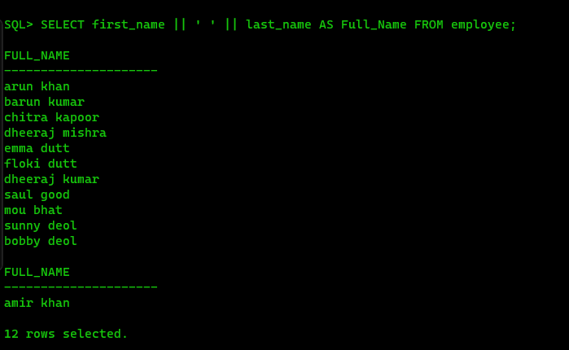

Q27: Show the f_name, l_name and job_type as Employees.

🡺 SELECT first_name, last_name, job_types AS Employees FROM employee;

Q28: Show the employee details in the following fassion:

Employees Details

--------------------------------------------------------

arun khan is a manager

barun kumar is a manager

……..

……..

🡺 SELECT first_name || ' ' || last_name || ' is a ' || job_types AS Employees_Details FROM employee;

Q29: Show the monthly salary details in the following fassion:

Monthly Salary Details

--------------------------------------------------------------------------------

arun's monthly salary is 90000

………

🡺 SELECT first_name || '''s monthly salary is ' || TO_CHAR(salary) AS Monthly_Salary_Detalil FROM employee;

Q30: Show the department names from the employee table.

🡺 select dept from employee;

Q31: Show the distinct department names from the employee table.

🡺 SELECT DISTINCT dept FROM employee;

Q32: Show the employees earning more than 50000.

🡺 SELECT * FROM employee WHERE salary > 50000;

Q33. Show the employee’s id’s who are not working under manager id-1.

🡺 SELECT employee_id FROM employee WHERE manager_id != 1;

Q34: Show the employee’s names and salaries whose salary ranges between 40000 to 70000.

🡺 SELECT first_name, last_name, salary FROM employee WHERE salary BETWEEN 40000 AND 70000;

Q35: Show the employees who work for manager id 1 or 6 or 8.

🡺 SELECT * FROM employee WHERE manager_id IN (1, 6, 8);

Q36: Select the first names and salaries of those employee whose last name is khan.

🡺 SELECT first_name, salary FROM employee WHERE last_name = 'khan';

Q37: Select the first names and salaries of those employee whose last name starts with k.

🡺 SELECT first_name, salary FROM employee WHERE last_name LIKE 'k%';

Q38: Select the first name, last name and salary of those employee whose last name starts with k and ends with r.

🡺 SELECT first_name, last_name, salary FROM employee WHERE last_name LIKE 'k%r';

Q39: Select the employees whose 3rd letter of their last name is o.

🡺 SELECT * FROM employee WHERE SUBSTR(last_name, 3, 1) = 'o';

Q40: Select the employees who are not working under any manager.

🡺 SELECT * FROM employee WHERE manager_id IS NULL;

Q41: Select the employees who work as engineers with salary greater than 50000.

🡺 SELECT * FROM employee WHERE job_types = 'engineer' AND salary > 50000;

Q42: Select the employees who work in the production department or earns more than 60000.

🡺 SELECT * FROM employee WHERE dept = 'production' OR salary > 60000;

Q43: Select those employees who are not managers or engineers or clerks.

🡺 SELECT * FROM employee WHERE job_types NOT IN ('manager', 'engineer', 'clerk');

Q44: Select the employees who earns more than 49000 or less than 29000.

🡺 SELECT * FROM employee WHERE salary > 49000 OR salary < 29000;

Q45. Select the employees who don’t have an ‘o’ as the 2nd last letter of their last name.

🡺 SELECT * FROM employee WHERE SUBSTR(last_name, -2, 1) != 'o';

Q46. Select the employees who get commission.

🡺 SELECT * FROM employee WHERE commission IS NOT NULL;

Q47. WAQ to display the current date.

🡺 SELECT SYSDATE AS current_date FROM dual;

Q48. Show the total experience in weeks for all the employees.

🡺 SELECT employee_id, first_name, last_name, doj, TRUNC((SYSDATE - doj) / 7) AS experience_in_weeks FROM employee;

Q49. Find the employees working under employee_id 2.

🡺 SELECT * FROM employee WHERE employee_id = 2;

Q50. Delete the employees from sales department if they are not working as managers.

🡺 DELETE FROM employee WHERE dept = 'sales' AND job_types != 'manager';

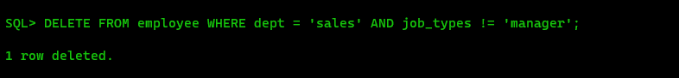

Q51. Insert the following two rows in the employee table without inserting any value in the department field.

🡺 insert into employee values (&employee_id, '&first_name', '&last_name', '&job_type', &salary, &commission, '&dept', &manager_id, '&doj');

Q52. . Insert the following two rows in the department table.

🡺 insert into department values ('&d_name', '&d_loc', &hod_id);

Q53. Update the employee table. Assign Anand to the admin department.

🡺 UPDATE employee SET dept = 'admin' WHERE first_name = 'anand';

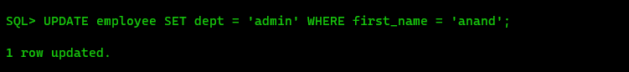

Q54. Update the manager_id from 2 to 1 in the employee table.

🡺 UPDATE employee SET manager_id = 1 WHERE manager_id = 2;

Q55. Display the employee details in descending order on their salary.

🡺 SELECT * FROM employee ORDER BY salary DESC;

Q56. Display the employee details in ascending order on their l_name.

🡺 SELECT * FROM employee ORDER BY last_name ASC;

Q57. Delete the employees who are working as salesmen and having less experience than 15 years.

🡺 DELETE FROM employee WHERE job_types = 'salesman' AND (SYSDATE - doj) / 365 < 15;

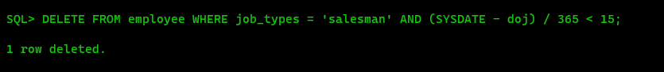

Q58. Commit the database.

🡺commit;

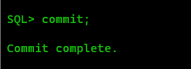

# **Assignment-III**

Name :- Bibek Chand Sah

Roll No. :- 22054029

Section :- CSE-05

1. Create a tabme emp12, with attributes empid, empname, phno, age, and emp_country. Make emp id the primary key of the table. Make empname not null, phno unique and put a check constraint on age which make sure employees are not below 18. Put a default value “India” on emp_country.

🡺 CREATE TABLE emp12 (empid INT CONSTRAINT empid_pk PRIMARY KEY, empname VARCHAR(10) CONSTRAINT empname_nn NOT NULL, phno VARCHAR(10) CONSTRAINT phno_uk UNIQUE, age INT CONSTRAINT age_ck CHECK (age >= 18), emp_country VARCHAR(10) DEFAULT 'India' );

2. Insert the following tuples into emp12 table.

🡺 INSERT INTO emp12 VALUES (&empid, '&empname', '&phno', &age, '&emp_country');

ALTER TABLE emp12 DROP CONSTRAINT empname_nn;

ALTER TABLE emp12 DROP CONSTRAINT phno_uk;

ALTER TABLE emp12 DROP CONSTRAINT empid_pk;

ALTER TABLE emp12 DROP CONSTRAINT age_ck;

3. Drop the check constraint on age.

🡺 ALTER TABLE emp12 DROP CONSTRAINT age_ck;

4. Put a default constraint with value 18 on age along with a check constraint which ensures age value is greater than or equal to 18 and less than or equal to 70.

🡺 ALTER TABLE emp12 ADD CONSTRAINT age_ck CHECK (age >= 18 AND age <= 70) NOVALIDATE;

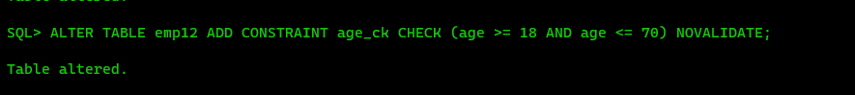

5. Insert the following rows in the emp12 table.

🡺 INSERT INTO emp12 VALUES (&empid, '&empname', '&phno', &age, '&emp_country');

6. Create table projectx with attributes pid, pname, phead, ploc and pmembers. pmembers should have a default value of 5. Make (pid,pname) the primary key. Use a constraint named uc_px_34 to make phead and ploc unique. Put a check constraint named ck_px_5 on pmembers which ensures that the number of pmembers must not exceed 5.

🡺 CREATE TABLE projectx ( pid INT, pname VARCHAR(50), phead VARCHAR(50), ploc VARCHAR(50), pmembers INT DEFAULT 5, CONSTRAINT pk_projectx PRIMARY KEY (pid, pname), CONSTRAINT uc_px_34 UNIQUE (phead, ploc), CONSTRAINT ck_px_5 CHECK (pmembers <= 5) );

7. Drop the primary key of the projectx table.

🡺 ALTER TABLE projectx DROP CONSTRAINT pk_projectx;

8. Put a constraint named pk_px_1 on pid, making pid the primary key of the table.

🡺 ALTER TABLE project DROP CONSTRAINT pk_projectx;

ALTER TABLE projectx ADD CONSTRAINT pk_px_1 PRIMARY KEY (pid);

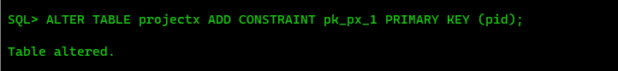

9. Insert the following rows in projectx table.

🡺 ALTER TABLE projectx MODIFY pid varchar2(10);

INSERT INTO projectx VALUES ('&pid', '&pname', '&phead', '&ploc', &pmembers);

10. Delete all rows from emp12 table except the rows having primary keys (112, 113, 114).

🡺 DELETE FROM emp12 WHERE empid NOT IN (112, 113, 114);

11. Insert a colunm named project in the emp12 table.

🡺 ALTER TABLE emp12 ADD project VARCHAR(10);

12. Update the table as following.

🡺 INSERT INTO emp12 VALUES (&empid, '&empname', '&phno', &age, '&emp_country', '&project');

13. Make the project attribute of the emp12 table a foreign key that links it to the pid attribute of the projectx table.

🡺 ALTER TABLE emp12 ADD CONSTRAINT fk_emp12_project FOREIGN KEY (project) REFERENCES projectx(pid);



14. Insert the following tuples in the emp12 table.

🡺 INSERT INTO emp12 VALUES (&empid, '&empname', '&phno', &age, '&emp_country', '&project');

ALTER TABLE emp12 DROP CONSTRAINT FK_EMP12_PROJECT;

15. Make the phead attribute of the projectx table a foreign key that links it to the empid attribute of the emp12 table.

🡺 ALTER TABLE project ADD CONSTRAINT fk_projectx_emp12 FOREIGN KEY (phead) REFERENCES emp12(empid);

ADD CONSTRAINT CFK FOREIGN KEY(PHEAD) REFERENCES EMP12(EMPID);

ALTER TABLE EMP12 MODIFY EMPID NUMBER PRIMARY KEY

Relation can’t be established until there are duplicate EMPIDs. Hence,

Delete duplicate empids (I.e Lily)

DELETE FROM EMP12 WHERE EMPNAME = 'Lily';

Make empid primary key

ALTER TABLE EMP12 MODIFY EMPID NUMBER PRIMARY KEY;

Create relation :

ALTER TABLE project ADD CONSTRAINT fk_phead_emp12 FOREIGN KEY (phead) REFERENCES emp12(empid);

16. Display all the constraints there are in emp12 table.

🡺 SELECT constraint_name, constraint_type, table_name FROM all_constraints WHERE table_name = 'EMP12';

17. Drop all the constraints in emp12 table one by one.

🡺 ALTER TABLE emp12 DROP CONSTRAINT pk_px_1;

ALTER TABLE emp12 DROP CONSTRAINT uc_px_34;

ALTER TABLE emp12 DROP CONSTRAINT ck_px_5;

18. Make emp_id the primary key of the employee table (of assignment 2).

🡺 ALTER TABLE employee ADD CONSTRAINT pk_employee PRIMARY KEY (emp_id);

19. Make the dept attribute of the employee table a foreign key refering to the department table (of assignment 2).

🡺 ALTER TABLE employee ADD CONSTRAINT fk_employee_department FOREIGN KEY (dept) REFERENCES department(dept_id);

20. Make d_name the primary key of the department table (of assignment 2).

🡺 ALTER TABLE department ADD CONSTRAINT pk_department PRIMARY KEY (d_name);

21. Make the dept attribute of the employee table a foreign key refering to the d_name attribute of the department table (of assignment 2)

🡺 ALTER TABLE employee ADD CONSTRAINT fk_employee_department FOREIGN KEY (dept) REFERENCES department(d_name);

# **Assignment-IV**

Name :- Bibek Chand Sah

Roll No. :- 22054029

Section :- CSE-05

1. WAQ to display the current date.

🡺 SELECT SYSDATE AS current_date FROM dual;

2. Assume that employees serve a six month provisional period starting from their DOJ. After 6 months they get permanent status. Display all the employees’ names, doj and the date on which they received their permanent status as permanent_date.

🡺 SELECT f_name, l_name, doj, doj + INTERVAL '6' MONTH AS permanent_date FROM employee;

3. WAQ to display the last date of this current month.

🡺 SELECT LAST_DAY(SYSDATE) AS last_date_of_month FROM dual;

4. For all the employees display their emp_id, f_name and their total experience in months.

🡺 SELECT employee_id, first_name, last_name, MONTHS_BETWEEN(SYSDATE, doj) AS total_experience_months FROM employee;

5. WAQ to display the date of next TUESDAY.

🡺 SELECT NEXT_DAY(SYSDATE, 'TUESDAY') AS next_tuesday_date FROM dual;

6. WAQ to extract the current month.

🡺 SELECT EXTRACT(MONTH FROM SYSDATE) AS current_month FROM dual;

7. WAQ to extract the current year.

🡺 SELECT EXTRACT(YEAR FROM SYSDATE) AS current_year FROM dual;

8. WAQ to display the absolute value of -505.

🡺 SELECT ABS(-505) AS absolute_value FROM dual;

9. WAQ to display the ceiling of 10.44 and 10.50 and 10.65.

🡺 SELECT CEIL(10.44) AS ceil_1, CEIL(10.50) AS ceil_2, CEIL(10.65) AS ceil_3 FROM dual;

10. WAQ to display the floor value of 10.44 and 10.50 and 10.65.

🡺 SELECT FLOOR(10.44) AS floor_1, FLOOR(10.50) AS floor_2, FLOOR(10.65) AS floor_3 FROM dual;

11. Find the logarithmic value of 10 base 2.

🡺 SELECT LOG(10, 2) AS logarithmic_value FROM dual;

12. Display the remainder in 594/7.

🡺 SELECT MOD(594, 7) AS remainder FROM dual;

13. WAQ to display the value of 8 to the power 3.

🡺 SELECT POWER(8, 3) AS power_value FROM dual;

14. WAQ to display the square root of 3481.

🡺 SELECT SQRT(3481) AS square_root FROM dual;

15. Display the following rounding operations- round(45.923,2), round(45.923,0), round(45.923,-1), round(45.923,2), round(45.923,0), round(45.923,-2).

🡺 SELECT ROUND(45.923, 2) AS round_1, ROUND(45.923, 0) AS round_2, ROUND(45.923, -1) AS round_3, ROUND(45.923, -2) AS round_4 FROM dual;

16. Display the following rounding operations- trunc(45.888,2), trunc(56.758,0), trunc(49.245,-2), trunc(45.888,2), round(45.888,2).

🡺 SELECT TRUNC(45.888, 2) AS trunc_1, TRUNC(56.758, 0) AS trunc_2, TRUNC(49.245, -2) AS trunc_3 FROM dual;

17. WAQ to return the sign of 20 and -67.60 and 0.

🡺 SELECT SIGN(20) AS sign_1, SIGN(-67.60) AS sign_2, SIGN(0) AS sign_3 FROM dual;

18. Display the value of cos(45), sin(45), and tan(45).

🡺 SELECT COS(45) AS cosine, SIN(45) AS sine, TAN(45) AS tangent FROM dual;

19. Display the ASCII character corresponding to the integer 79.

🡺 SELECT CHR(79) AS ascii_character FROM dual;

20.Display the f_name and l_name together using the concat() function.

🡺 SELECT CONCAT ('Bibek', 'Sah') FROM DUAL;

21. Display all the f_names in capital letters.

🡺 SELECT UPPER(first_name) AS capital_f_name FROM employee;

22. Find the length of the first name and last name of all the employees who work in the sales department.

🡺 SELECT LENGTH(first_name) AS first_name_length, LENGTH(last_name) AS last_name_length FROM employee WHERE dept = 'sales';

23. Determine the tax-rate for each employee based on their monthly salary. The tax-rates are

as per the following table. If salary is < 2000 then tax rate is 0 %, 20000<=salary<40000 9%, 40000<=salary<60000 20%, 60000<=salary<80000 30%, salary>=80000 45%

🡺 SELECT employee_id, first_name, last_name, salary, CASE WHEN salary < 2000 THEN 0 WHEN salary >= 20000 AND salary < 40000 THEN 9 WHEN salary >= 40000 AND salary < 60000 THEN 20 WHEN salary >= 60000 AND salary < 80000 THEN 30 WHEN salary >= 80000 THEN 45 END AS tax_rate FROM employee;

24. Find the average salary, maximum salary, minimum salary and the sum of salaries from the employee table.

🡺 SELECT AVG(salary) AS average_salary, MAX(salary) AS maximum_salary, MIN(salary) AS minimum_salary, SUM(salary) AS total_salary FROM employee;

25. Find the average salary, maximum salary, minimum salary and the sum of salaries of the

employees who work for the sales department.

🡺 SELECT AVG(salary) AS average_salary, MAX(salary) AS maximum_salary, MIN(salary) AS minimum_salary, SUM(salary) AS total_salary FROM employee WHERE dept = 'sales';

26. Find the newest and oldest employee.

🡺 SELECT MAX(doj) AS newest_employee, MIN(doj) AS oldest_employee FROM employee;

27. Find those two employees whose l_name comes first and last in alphabetical order.

🡺 SELECT MIN(last_name) AS first_employee, MAX(last_name) AS last_employee FROM employee;

28. Find the number of engineers.

🡺 SELECT COUNT(*) AS num_engineers FROM employee WHERE job_types = 'engineer';

29. Find the number of departments from the employee table.

🡺 SELECT COUNT(DISTINCT dept) AS num_departments FROM employee;

30. Find the average commission from the employee table.

🡺 SELECT AVG(commission) AS average_commission FROM employee;

1. Find the date of next Sunday.

🡺 select next_day(sysdate,'sunday') from dual;

1. Find 7 raised to the power 7.

🡺select power(7,7) from dual;

1. Input your name(first_name last_name) in upper case “JAYANTA MONDAL”. The output should come under the alias MY_NAME and the name should appear in lower_case but the first letter of first_name and last_name should be in upper_case.

è SELECT INITCAP('JAYANTA MONDAL') AS NAME FROM DUAL;

1. Create and insert the following:       STUDENT12

|  |  |  |  |
| --- | --- | --- | --- |
| Roll_No | Name | CGPA | DOB |
| 120 | Avi | 6.55 | 09-Jan-2000 |
| 134 | Beena | 8.20 | 31-Aug-2002 |
| 155 | Charu | 8.20 | 23-Dec-1999 |
| 202 | Dawar | 9.15 | 09-Jan-2000 |

🡺 CREATE TABLE student12 ( roll_no number, name varchar(10), cgpa number, dob date );



INSERT INTO student12 VALUES (&roll_no, '&name', &cpga, '&dob')

1. Say, stipend is given to all students. 10000 if cgpa>9, 7000 if cgpa>8, 5000 if cgpa>7, rest are given 1000 rupees. List the students name and stipend received by them.

🡺 select Roll_no,name,CGPA,decode(trunc(CGPA,0),9,10000,8,7000,7,5000,1000) as stipend from student12;

1. Show the students name in upper_case, and DOB in the following format : five-february-two thousand twenty-four.

è select upper(name), to_char(dob,'ddsp-month-yyyysp') dob from student12;

1. Count the number of students present in the student12 table.

🡺 SQL> select count(*) as student_count from student12;

1. Select the average age of the students.

🡺 SELECT AVG(EXTRACT(YEAR FROM SYSDATE) - EXTRACT(YEAR FROM DOB)) as average_age FROM student12;

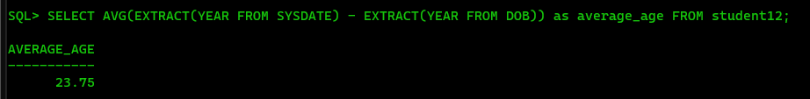

1. Make the set of name,cgpa and DOB, the primary key of the student12 table.

🡺 ALTER TABLE student12 ADD CONSTRAINT pk_student12 PRIMARY KEY (name, cgpa, DOB);



1. Make roll_no the new primary key of the table.

🡺 ALTER TABLE student12 DROP CONSTRAINT pk_student12;

ALTER TABLE student12 ADD CONSTRAINT pk_student12 PRIMARY KEY (roll_no);

# **Assignment-V**

Name :- Bibek Chand Sah

Roll :- 22054029

Branch :- CSE

Section :- CSE-05

1. Find the average salary of each department.

🡺 SELECT dept, AVG(salary) AS average_salary FROM employee GROUP BY dept;

2. Find the average salary for each jobtype according to each department.

🡺 SELECT dept, job_types, AVG(salary) AS average_salary FROM employee GROUP BY dept, job_types;

3. Find the department names and their corresponding average salary where the average

salary is greater than 40000.

🡺 SELECT dept, AVG(salary) AS average_salary FROM employee GROUP BY dept HAVING AVG(salary) > 40000;

4. Select the departments where the maximum salary is more than 55000.

🡺 SELECT dept FROM employee GROUP BY dept HAVING MAX(salary) > 55000;

5. Find the department names and their average salary where the maximum salary of the

department is higher than 55000.

🡺 SELECT dept, AVG(salary) AS average_salary FROM employee GROUP BY dept HAVING MAX(salary) > 55000;

6. Display the job_types and the total monthly salary for each jobtypes as “PAYROLL”, where

the total payroll according to jobtypes exceeds 100000/month.

🡺 SELECT job_types, SUM(salary) AS total_salary FROM employee GROUP BY job_types HAVING SUM(salary) > 100000;

7. Display the job_types and the total monthly salary for each jobtypes as “PAYROLL”, where

the total payroll according to jobtypes exceeds 100000/month and jobtype is not engineer.

🡺 SELECT job_types, SUM(salary) AS total_salary FROM employee WHERE job_types != 'engineer' GROUP BY job_types HAVING SUM(salary) > 100000;

8. Display the job_types and the total monthly salary for each jobtypes as “PAYROLL”, where

the total payroll according to jobtypes exceeds 60000/month and jobtype is not engineer

and sort the list in ascending order of sum of salary.

🡺 SELECT job_types, SUM(salary) AS total_salary FROM employee WHERE job_types != 'engineer' GROUP BY job_types HAVING SUM(salary) > 60000 ORDER BY SUM(salary) ASC;

9. Display the job_types and the total monthly salary for each jobtypes as “PAYROLL”, where

the total payroll according to jobtypes exceeds 50000/month and jobtype is not engineer

and sort the list in descending order of sum of salary.

🡺 SELECT job_types, SUM(salary) AS total_salary FROM employee WHERE job_types != 'engineer' GROUP BY job_types HAVING SUM(salary) > 50000 ORDER BY SUM(salary) DESC;

10. Find the maximum average salary according to departments.

🡺 SELECT DEPT, AVG_SALARY AS MAX_AVG_SALARY FROM (SELECT DEPT, AVG(SALARY) AS AVG_SALARY FROM EMPLOYEE GROUP BY DEPT) Subquery WHERE AVG_SALARY = (SELECT MAX(AVG_SALARY) FROM (SELECT AVG(SALARY) AS AVG_SALARY FROM EMPLOYEE GROUP BY DEPT ));

11. Find the minimum average salary according to jobtypes.

🡺 SELECT MIN(AVG(SALARY)) AS MIN_AVG_SALARY FROM EMPLOYEE GROUP BY JOB_TYPES;

12. Find the employee name and date of joining who are working in delhi.

🡺 SELECT e.FIRST_NAME || ' ' || e.LAST_NAME AS EMPLOYEE_NAME, e.DOJ FROM EMPLOYEE e JOIN DEPARTMENT d ON e.DEPT = d.D_NAME WHERE d.D_LOC = 'delhi';

13. Create the table ‘Emp_Address’ for storing the permanent address of the employees and

insert the values.

🡺 CREATE TABLE Emp_Address (emp_id INT, city VARCHAR(15), district VARCHAR(15), state VARCHAR(15));

INSERT INTO Emp_Address VALUES (&emp_id, '&city', '&district', '&state');

14. Display the employee name with their home city and the city they work in.

🡺 SELECT e.FIRST_NAME || ' ' || e.LAST_NAME AS Employee_Name, a_home.City AS Home_City, d.D_LOC AS Working_City FROM EMPLOYEE e JOIN EMP_ADDRESS a_home ON e.EMP_ID = a_home.EMP_ID JOIN DEPARTMENT d ON e.DEPT = d.D_NAME;

15. Create the following Job_Grades table.

🡺 CREATE TABLE JOB_GRADES (GRADE VARCHAR2(5), LOWEST_SAL NUMBER(10), HIGHEST_SAL NUMBER(10));

INSERT INTO JOB_GRADES VALUES('A',10000,24999);

INSERT INTO JOB_GRADES VALUES('B',25000,49999);

INSERT INTO JOB_GRADES VALUES('C',50000,100000);

16. Display the employee names along with their salary and job_grade.

🡺 SELECT e.FIRST_NAME || ' ' || e.LAST_NAME AS EMPLOYEE_NAME, e.SALARY, j.GRADE FROM EMPLOYEE e JOIN JOB_GRADES j ON e.SALARY BETWEEN j.LOWEST_SAL AND j.HIGHEST_SAL;

17. Display the employees name along with their manager’s name. (use SELF JOIN)

🡺 SELECT e1.FIRST_NAME AS Employee_Name, e2.FIRST_NAME AS Manager_Name FROM EMPLOYEE e1 JOIN EMPLOYEE e2 ON e1.MANAGER_ID = e2.EMPLOYEE_ID;

18. Display emp_id, f_name, d_loc, and hod_id (using natural join).

🡺 SELECT EMPLOYEE.EMPLOYEE_ID, EMPLOYEE.FIRST_NAME, DEPARTMENT.D_LOC, DEPARTMENT.HOD_ID FROM EMPLOYEE NATURAL JOIN DEPARTMENT;

19. Display the employees f_name, city and state in which they live (using natural join).

🡺 SELECT EMPLOYEE.FIRST_NAME, EMP_ADDRESS.CITY, EMP_ADDRESS.STATE FROM EMPLOYEE NATURAL JOIN EMP_ADDRESS;

20. Display the employees emp_id, f_name, d_loc, hod_id using inner join.

🡺 SELECT EMPLOYEE.EMPLOYEE_ID, EMPLOYEE.FIRST_NAME, DEPARTMENT.D_LOC, DEPARTMENT.HOD_ID FROM EMPLOYEE INNER JOIN DEPARTMENT ON EMPLOYEE.DEPT = DEPARTMENT.D_NAME;

21. Display the employees f_name, city and state in which they live (using inner join).

🡺 SELECT EMPLOYEE.FIRST_NAME, EMP_ADDRESS.CITY, EMP_ADDRESS.STATE FROM EMPLOYEE INNER JOIN EMP_ADDRESS ON EMPLOYEE.EMP_ID = EMP_ADDRESS.EMP_ID;

22. Display the employees f_name, city and state in which they live (using join keyword).

🡺 SELECT EMPLOYEE.FIRST_NAME, EMP_ADDRESS.CITY, EMP_ADDRESS.STATE FROM EMPLOYEE JOIN EMP_ADDRESS ON EMPLOYEE.EMP_ID = EMP_ADDRESS.EMP_ID;

23. Insert the following two rows in the employee table without inserting any value in the

department field.

🡺 INSERT INTO EMPLOYEE VALUES(20,'ALEX',NULL,'ENGINEER',28000,2000,NULL,1,TO_DATE('31-JAN-2017','DD-MM-YYYY'));

INSERT INTO EMPLOYEE VALUES(21,'PRIYA','PATEL','CLERK',12000,500,NULL,1,TO_DATE('01-APR-2017','DD-MM-YYYY'));

24. Insert the following two rows into the department table.

🡺 INSERT INTO DEPARTMENT VALUES('TRAINING','MUMBAI',1);

INSERT INTO DEPARTMENT VALUES('PLACEMENT','MUMBAI',1);

25. Display the employees f_name, city and state in which they live after joining employee

and employee_address table using left outer join.

🡺 SELECT EMPLOYEE.FIRST_NAME, EMP_ADDRESS.CITY, EMP_ADDRESS.STATE FROM EMPLOYEE LEFT JOIN EMP_ADDRESS ON EMPLOYEE.EMP_ID = EMP_ADDRESS.EMP_ID;

26. Display the employees f_name and their work location after joining employee and

department table using left join.

🡺 SELECT EMPLOYEE.FIRST_NAME, DEPARTMENT.D_LOC AS WORK_LOCATION FROM EMPLOYEE LEFT JOIN DEPARTMENT ON EMPLOYEE.DEPT = DEPARTMENT.D_NAME;

27. Display the employees f_name and their work location after joining employee and

department table using right join.

🡺 SELECT EMPLOYEE.FIRST_NAME, DEPARTMENT.D_LOC AS WORK_LOCATION FROM EMPLOYEE RIGHT JOIN DEPARTMENT ON EMPLOYEE.DEPT = DEPARTMENT.D_NAME;

28. Display the employees f_name and their work location after joining employee and

department table using full join/full outer join.

🡺 SELECT EMPLOYEE.FIRST_NAME, DEPARTMENT.D_LOC AS WORK_LOCATION FROM EMPLOYEE FULL JOIN DEPARTMENT ON EMPLOYEE.DEPT = DEPARTMENT.D_NAME;

29. Find the employees who are working in their home city.

🡺 SELECT e.EMP_ID, e.FIRST_NAME, e.LAST_NAME FROM EMPLOYEE e JOIN DEPARTMENT d ON e.DEPT = d.D_NAME JOIN EMP_ADDRESS ea ON e.EMP_ID = ea.EMP_ID WHERE d.D_LOC = ea.CITY;

30. Find the job type having the minimum average salary according to jobtypes.

🡺 SELECT JOB_TYPE, AVG(SALARY) AS AVERAGE_SALARY FROM EMPLOYEE GROUP BY JOB_TYPE ORDER BY AVG(SALARY) ASC FETCH FIRST 1 ROW ONLY;

# **Assignment-VI**

Name:- Bibek Chand Sah

Roll:- 22054029

Section:- CSE-05

1. Create and populate the following table ‘EMP06’. Make Emp_no the primary key and F_name not null.

🡺 CREATE TABLE EMP06 (Emp_no INT PRIMARY KEY, F_name VARCHAR(50) NOT NULL, L_name VARCHAR(50), Salary DECIMAL(10, 2), Dept_no INT);

INSERT INTO EMP06 VALUES (&Emp_no, '&F_name', '&L_name', &Salary, &Dept_no);

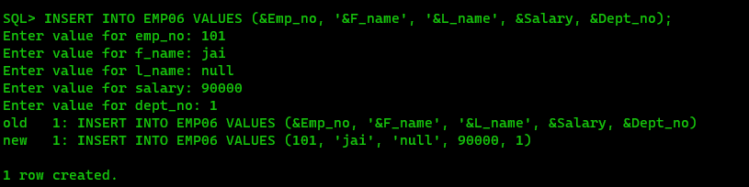

2. Create and populate the following table ‘PROJECT’. Make P_no the primary key and put a default value constraint on P_Loc with value=‘Mumbai’.

🡺 CREATE TABLE PROJECT (P_no INT PRIMARY KEY, P_name VARCHAR(50), P_Loc VARCHAR(50) DEFAULT 'Mumbai');

INSERT INTO PROJECT VALUES (&P_no, ‘&P_name’, ‘&P_Loc’);

3. Create and populate the following EMP_PROJ table. Make(Emp_no, P_no) the primary key.

🡺 CREATE TABLE EMP_PROJ (Emp_no INT, P_no INT, PRIMARY KEY (Emp_no, P_no));

INSERT INTO EMP_PROJ VALUES (&Emp_no, &P_no);

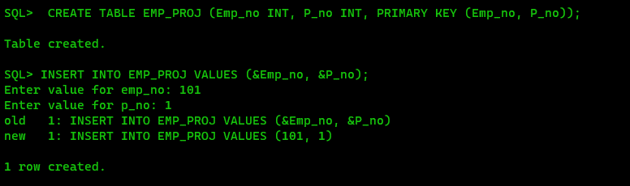

4. Display the employee’s first names with the project name’s they are working on.

🡺 SELECT e.first_name, p.project_name FROM EMP06 e JOIN Project_Assignment pa ON e.employee_id = pa.employee_id JOIN Project p ON pa.project_id = p.project_id;

5. In which city Gabbar Singh works.

🡺 SELECT e.city FROM Employee e WHERE e.first_name = 'Gabbar' AND e.last_name = 'Singh';

6. Find the employee names who are not yet assigned to any project (using minus).

🡺 SELECT first_name, last_name FROM Employee MINUS SELECT e.first_name, e.last_name FROM Employee e JOIN Project_Assignment pa ON e.employee_id = pa.employee_id;

7. Find the employee names who are not yet assigned to any project (using outer join).

🡺 SELECT e.first_name, e.last_name FROM Employee e LEFT JOIN Project_Assignment pa ON e.employee_id = pa.employee_id WHERE pa.employee_id IS NULL;

8. Find the project names where no employees are working (using outer join).

🡺 SELECT p.project_name FROM Project p LEFT JOIN Project_Assignment pa ON p.project_id = pa.project_id WHERE pa.project_id IS NULL;

9. Find all the employee names who are working in project number 1 and project ‘ABC’ (using union).

🡺 (SELECT e.first_name, e.last_name FROM Employee e JOIN Project_Assignment pa ON e.employee_id = pa.employee_id JOIN Project p ON pa.project_id = p.project_id WHERE p.project_id = 1) UNION (SELECT e.first_name, e.last_name FROM Employee e JOIN Project_Assignment pa ON e.employee_id = pa.employee_id JOIN Project p ON pa.project_id = p.project_id WHERE p.project_name = 'ABC');

10. Find all the employee names who are working in both project number 1 and project number 2 (using intersect).

🡺 (SELECT e.first_name, e.last_name FROM Employee e JOIN Project_Assignment pa ON e.employee_id = pa.employee_id WHERE pa.project_id = 1) INTERSECT (SELECT e.first_name, e.last_name FROM Employee e JOIN Project_Assignment pa ON e.employee_id = pa.employee_id WHERE pa.project_id = 2);

11. Find the number of employees working in each project.

🡺 SELECT p.project_name, COUNT(pa.employee_id) AS num_employees FROM Project p JOIN Project_Assignment pa ON p.project_id = pa.project_id GROUP BY p.project_name;

12. Find the average salary of each department.

🡺 SELECT d.dept_name, AVG(e.salary) AS avg_salary FROM Department d JOIN Employee e ON d.dept_id = e.dept_id GROUP BY d.dept_name;

13. Find the department number with the number of employees working in each department where the average salary is greater than 60000 and number of employees greater than 1.

🡺 SELECT d.dept_id, COUNT(e.employee_id) AS num_employees FROM Department d JOIN Employee e ON d.dept_id = e.dept_id GROUP BY d.dept_id HAVING AVG(e.salary) > 60000 AND COUNT(e.employee_id) > 1;

14. Find all the employees who earn more than Basanti.

🡺 SELECT e.first_name, e.last_name FROM Employee e WHERE e.salary > (SELECT salary FROM Employee WHERE first_name = 'Basanti');

15. Find all the employees who earn more than the average salary of all employees.

🡺 SELECT e.first_name, e.last_name FROM Employee e WHERE e.salary > (SELECT AVG(salary) FROM Employee);

16. Find the employee who earns the highest salary.

🡺 SELECT first_name, last_name FROM Employee WHERE salary = (SELECT MAX(salary) FROM Employee);

17. Find the employee who earns the highest salary in dept_no 3.

🡺 SELECT first_name, last_name FROM Employee WHERE salary = (SELECT MAX(salary) FROM Employee WHERE dept_id = 3);

18. Find the employee earning the second highest salary.

🡺 SELECT first_name, last_name FROM Employee WHERE salary = (SELECT MAX(salary) FROM Employee WHERE salary < (SELECT MAX(salary) FROM Employee));

19. Find the dept_no having the highest average salary.

🡺 SELECT dept_id FROM Employee GROUP BY dept_id HAVING AVG(salary) = (SELECT MAX(avg_salary) FROM (SELECT AVG(salary) AS avg_salary FROM Employee GROUP BY dept_id));

20. Find the employee with the third highest salary among all the employees

🡺 SELECT first_name, last_name FROM Employee WHERE salary = (SELECT DISTINCT salary FROM Employee ORDER BY salary DESC LIMIT 1 OFFSET 2);